**CBM1 - Classroom Organization for Productivity**

1. **Arrangement**: Desks are arranged in clusters of 4 to encourage collaboration and group work, with a few individual desks for students who might need fewer distractions.
2. **Placement**: Special considerations for tall students, quiet students, well-behaved students, students who sleep in class, and students in wheelchairs.

**Classroom Layout Plan**

* **Front of Classroom**: Teacher’s desk and board.
* **Clusters of Desks**: Five clusters of four desks each, plus five individual desks for special needs.
* **Special Desks**: Arranged to accommodate specific student needs.

Here’s a rough description before creating the visual:

* **Cluster 1**:
  + Desk 1: T (Tall Student) o Desk 2: T (Tall Student) o Desk 3: Regular Student o Desk 4: Regular Student
* **Cluster 2**:
  + Desk 1: Q (Quiet Student) o Desk 2: Checkmark (Well-Behaved Student) o Desk 3: Regular Student o Desk 4: Regular Student
* **Cluster 3**:
  + Desk 1: Checkmark (Well-Behaved Student) o Desk 2: Regular Student
  + Desk 3: Regular Student o Desk 4: Regular Student • **Cluster 4**:
  + Desk 1: Regular Student o Desk 2: Regular Student o Desk 3: Regular Student o Desk 4: Regular Student • **Cluster 5**:
  + Desk 1: Regular Student o Desk 2: Regular Student o Desk 3: Regular Student o Desk 4: Regular Student
* **Individual Desks**:
  + Desk 1: S (Sleeps in Class) – near the front to monitor closely. o Desk 2: W (Wheelchair) – with space for accessibility.
  + Desk 3: Regular Student o Desk 4: Regular Student o Desk 5: Regular Student

Now, I'll create this layout in PowerPoint and save it for you.

**Classroom Layout and Seating Chart**:

**Key**:

* **T**: Tall Student
* **Q**: Quiet Student
* ✔: Well-Behaved Student
* **S**: Sleeps in Class
* **W**: Wheelchair

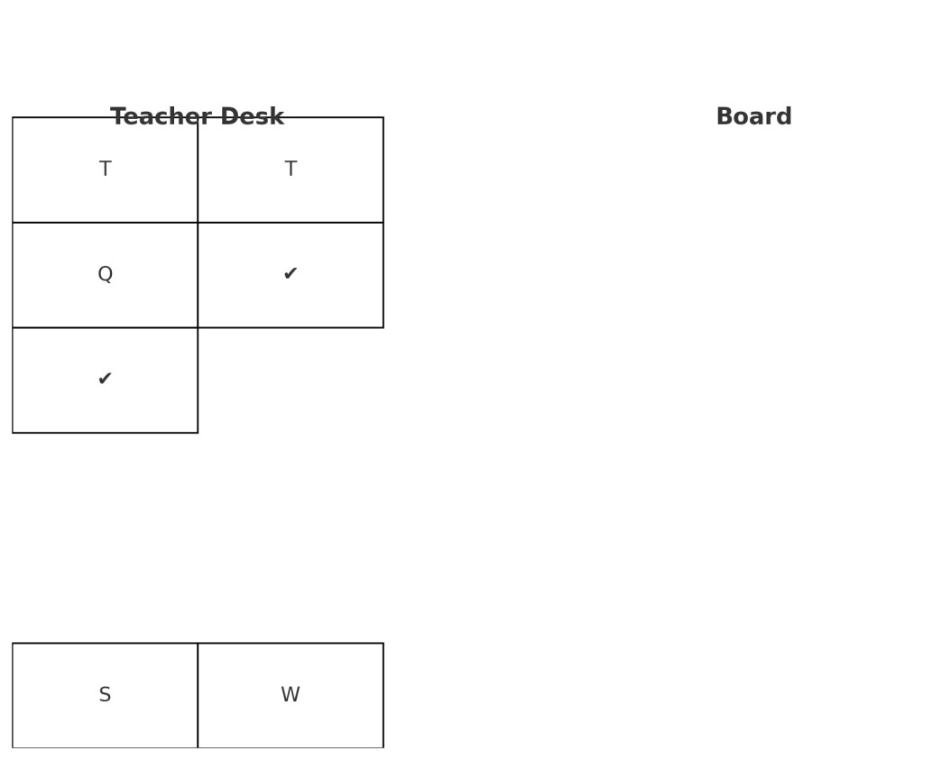

Here is the classroom layout and seating chart for your assignment. The key placements of students with specific needs are indicated as follows:

* **T**: Tall Student
* **Q**: Quiet Student
* ✔: Well-Behaved Student
* **S**: Sleeps in Class
* **W**: Wheelchair